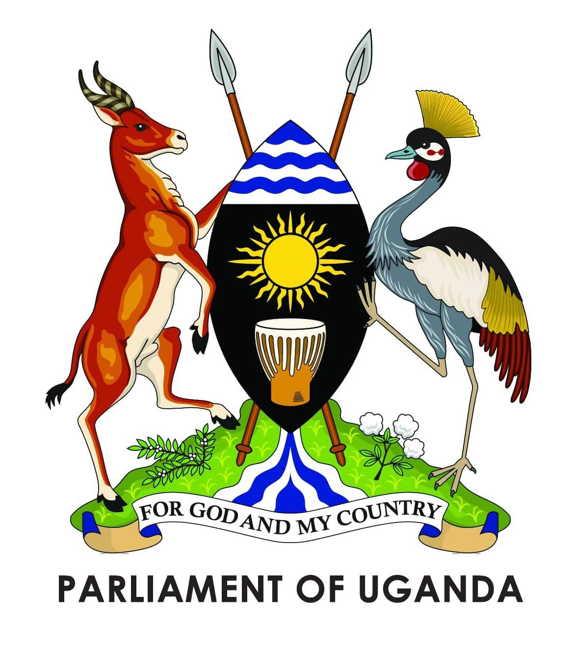

Parliamentary Information Summary – Plenary
31 October – 04 November 2022

Date | Mover | Subject | Brief about Subject | Action/House/Speaker’s Decision
01 Nov 2022 | Hon. Margaret Muhanda (NRM, Fort Portal North Division ) Minister of State for Health | Statement By Minister On Progress In Combating The Ebola Outbreak In The Country | Following the outbreak of the disease, Parliament expected to receive a report on the measures being taken to combat it | Hon. Muhanga requested the House for extra time to allow the senior minister presented the statement. The Speaker directed that the minister does so the next day
01 Nov 2022 | Hon. Henry Musasizi (NRM, Rubanda East) Minister of State for Finance (General Duties) | Laying of Papers | Request to borrow up to Euro 455.03 million (equiv. to US$464.13 million) from Standard Chartered Bank and other finance institutions to finance the development and infrastructure budget for the fiscal year 2022/23 | Referred to the Committee of National Economy
01 Nov 2022 | Hon. Henry Musasizi (NRM, Rubanda East) Minister of State for Finance (General Duties) | Laying of papers | Request to borrow up to Special Drawing Rights(SDR) 237.7 (equivalent to US$ 331.5 Million) and receive a grant of up to SDR198.2 Million (equivalent to US$ 276.5 Million) from the International Development Association of the World Bank Group to finance the Electricity Access Scale Up Project | Referred to the Committee of National Economy
01 Nov 2022 | Hon. Henry Musasizi (NRM, Rubanda East) Minister of State for Finance (General Duties) | Laying of papers | Request to borrow up to Special Drawing Rights (SDR) 98.8 million (equivalent to US$ 140 million) and secure a grant financing amounting to SDR 42.4 million (equivalent to US$ 60 million) from the International Development Association (IDA) of the World Bank to finance the Uganda Digital Acceleration Project (UDAP) – Government Network (GOVNET) | Referred to the Committee of National Economy
01 Nov 2022 | Hon. Solomon Silwany (NRM, Bukooli Central) Parliamentary Commission | Laying of papers | Report of the Auditor General on the financial statements of National Social Security Fund for the year ended 30 June 2022 | Referred to the Public Accounts Committee (Commission, Statutory Authorities and State Enterprises)
01 Nov 2022 | Hon. Solomon Silwany (NRM, Bukooli Central) Parliamentary Commission | Laying of papers | Report of the Auditor General on the financial statements of the 8th UNFPA Country Programme GPECMUGA, UGA09GBV, UGA09SRH, UGA09WYP, ZZTOGUGA implemented by Ministry of Education and Sports for the year ended 31 December 2021 | Referred to the Public Accounts Committee (Central Government)
01 Nov 2022 | Hon. Solomon Silwany (NRM, Bukooli Central) Parliamentary Commission | Laying of papers | Report of the Auditor General on the financial statements of the UNFPA funded Programme UGA09GBV/PGUG12 implemented by Ministry of Gender, Labour and Social Development for the nine month period ended 30 September 2021 | Referred to the Public Accounts Committee (Central Government)
01 Nov 2022 | Hon. Solomon Silwany (NRM, Bukooli Central) Parliamentary Commission | Laying of papers | Report of the Auditor General on the financial statements of the 8th UNFPA Country Programme GPECMUGA And UGA09GBV implemented by Ministry of Justice and Constitutional Affairs for the year ended 31 December 2021 | Referred to the Public Accounts Committee (Central Government)
01 Nov 2022 | Hon. Solomon Silwany(NRM, Bukooli Central ) Parliamentary Commission | Laying of papers | Report of the Auditor General on the financial statements of UNFPA funded Programme Component of Data and Population Dynamics implemented by National Planning Authority for the year ended 31 December 2021 | Referred to the Public Accounts Committee (Commission, Statutory Authorities and State Enterprises)
01 Nov 2022 | Hon. Solomon Silwany(NRM, Bukooli Central) Parliamentary Commission | Laying of papers | Report of the Auditor General on the financial statements of UNFPA funded Programme Component of Data and Population Dynamics implemented by Uganda Bureau of Statistics for the year ended 31 December 2021 | Referred to the Public Accounts Committee (Commission, Statutory Authorities and State Enterprises)
01 Nov 2022 | Hon. Martin Ojara Mapenduzi(Indep., Bardege-Layibi Division, Gulu City) Chairperson, PAC (Local Government) | Motion for adoption of the report of the Public Accounts Committee (Local Government) on the report of the Auditor General for financial year 2020/2021 on four district local governments and two municipal councils | The report covers Apac district, Nansana Municipality, Makindye- Ssabagabo Municipality, Kira  Municipality, Mityana and Butambala District Iocal governments | Presentation of the report deferred due to the absence of sector ministers
02 Nov 2022 | Hon. Margaret Muhanda(NRM, Fort Portal North Division) Minister of State for Health | Statement by minister on progress in combating the Ebola outbreak in the country | On 20 September 2O22, the Ministry of Health declared an outbreak of the Ebola- Sudan virus in the district of Mubende. The outbreak then spread to affect four other districts including Kasanda, Kagadi, Bunyangabu, and Kyegegwa within a period of two week. | The Minister informed the House about the containment measures saying that a response plan costed at shs76 billion was developed & presented to cabinet and been submitted to the Finance Ministry for funding. She added that the ministry will also start vaccine trials soon
02 Nov 2022 | Hon. Solomon Silwany(NRM, Bukooli Central ) Parliamentary Commission | Laying of papers | Bi-annual Inspectorate of Government Performance Report to Parliament, January –June 2021 | Referred to the Legal and Parliamentary Affairs Committee
02 Nov 2022 | Hon. Solomon Silwany(NRM, Bukooli Central ) Parliamentary Commission | Laying of papers | Bi-annual Inspectorate of Government Performance Report to Parliament July – December 2021 | Referred to the Legal and Parliamentary Affairs Committee
02 Nov 2022 | Hon. Henry Musasizi (NRM, Rubanda East) Minister of State for Finance (General Duties) | Laying of papers | Schedule of quarterly releases for quarter I and II of the budget of financial year 2022/2023 | The schedule was for information purposes to the House
02 Nov 2022 | Hon. Margret Rwabushaija  Namubiru (Indep., Workers) | Motion for reconsideration of the Parliamentary Pensions (Amendment) Bill, 2022 as returned by the President | Parliament had passed the bill earlier with an amendment to have government increase the contribution of Members of Parliament from 30 to 40 per cent. However, the President declined to assent to it stating that the Ministry of Finance advised that the Bill that was presented to them did not include amendments to increase government contribution. The committee agreed with him | Bill passed at Third Reading
 | Hon Ruth Aceng (NRM, Lira City) Minister for Health | Motion for reconsideration of the Public Health (Amendment) Bill, 2022 as returned by the President | The President also returned this bill to the House for reconsideration having raised concern on the use of the word “vaccination” and not “immunisation”. He was also concerned about the time taken to seek authorization to destroy items infected with a disease. The Health committee also conceded. | Bill passed at Third Reading
03 Nov 2022 | Hon. Henry Musasizi (NRM, Rubanda East) Minister of State for Finance (General Duties) | Laying of papers | Annual Macroeconomic and Fiscal performance report for financial year 2021/22 | Referred to the Budget Committee
03 Nov 2022 | Hon Ruth Aceng (NRM, Lira City) Minister for Health | Laying of papers | Statutory instruments on the regulation of Ebola in Uganda | Presented for information to the House
03 Nov 2022 | Hon Martin Ojara Mapenduzi (Indep., Bardege-Layibi Division, Gulu City) Chairperson, PAC (Local Government) | Motion for adoption of the report of the Public Accounts Committee (Local Government) on the report of the Auditor General for financial year 2020/2021 on four district local governments and two municipal councils | The report covers Apac district, Nansana Municipality, Makindye- Ssabagabo Municipality, Kira  Municipality, Mityana and Butambala District Iocal governments. The Committee revealed that all these lower governments had similar issues of mismanagement of payrolls, mismatch between recruitment plans and the actual recruitment among others. The committee recommended that the accounting officers be reprimanded | Motion adopted
03 Nov 2022 | Hon. Henry Musasizi (NRM, Rubanda East) Minister of State for Finance (General Duties) | Motion for resolution of Parliament to authorize government to borrow up to Euro 455.03 million (equiv. to US$ 464.13 million) from Standard Chartered Bank and other finance institutions to finance the Development and Infrastructure Budget for the financial year 2022/23 | The government says that the loan will pay outstanding infrastructure certificates among others to avoid accumulating arrears during the financial year.  The minister informed the House that because of financial constraints, government managed to only finance seven per cent of the different votes’ development expenditure, which he said will have an effect on budget performance and economic recovery | Motion adopted

The Speaker adjourned the House to Tuesday, 08 November 2022.

